WOULD YOU LIKE INSERVICE CREDIT FOR THE NCTE CONVENTION?

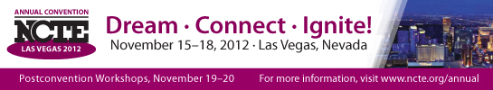

You must be a NEVADA teacher!

You must attend 15 hours OUTSIDE of contract time (Thursday evening, Friday afternoon, Saturday, and Sunday)!

You must submit a ONE PAGE reflective summary detailing your conference learning!

To earn credit:

Please submit a record of sessions attended AND reflective summary to Kim Cuevas at kcuevas@washoeschools.net by December 1, 2012. Your certificate will be mailed.

