Young Children Writing by Lorraine Wilson
Parents are often concerned about the way their young children are allowed to write in the classrooms today. Many Mums and Dads remember their days at school, and how they had to try to avoid errors of spelling and punctuation.
Today, a child’s errors or a child’s approximation of conventional writing, are seen as a rich resource for revealing just what a child understands about writing, about spelling and other writing conventions.
Let’s look closely at six year old Kara’s writing, done on the first day of her Grade 1 year.

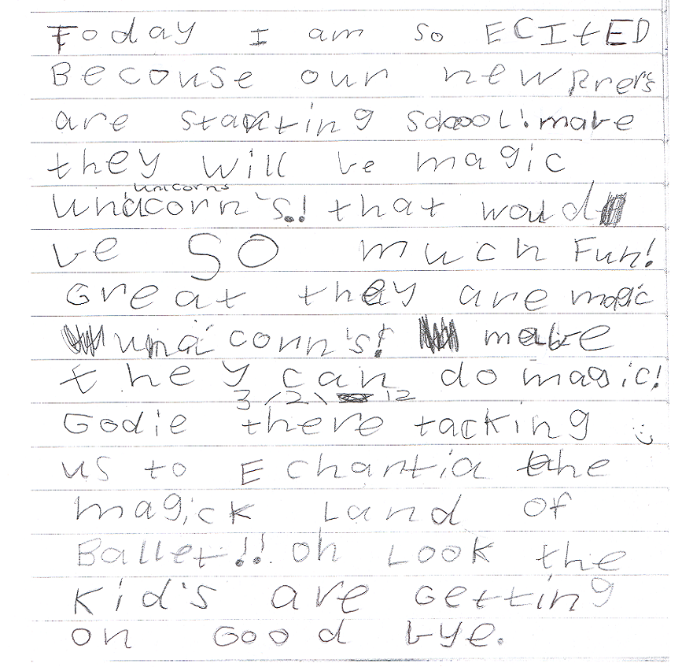
Kara is part of a K/I class at her local primary school. The Grade 1 children started the new school year ,one day before their Kindergarten classmates. All of the Grade 1 children were expected to write something of their own choosing, on that first day. Kara chose to write about her excitement at the prospect of meeting the new Kindergarten children on the following day. Note the second date half way through the piece of writing. Kara happily continued drafting her piece on the following day.
When the children write with a focus on meaning, and without fear of making errors, we, the teachers, get insights into both what the child knows about writing, and what teaching is relevant for that child right now. Let’s look closely at what Kara knows.
What Does Kara Know About Writing?
- Writing expresses meaning.
- Writing can be fantasy.
- Writing does not have to be finished in one go.
- She knows basic print conventions – directionality, word, letter.
- She uses many conventional spellings (eg today, our, new, they, magic, ballet, are, getting,).
- As well as words, writing includes punctuation (eg full stop, exclamation mark)
- Her phonemic awareness is very good. She is hearing every sound in each word: (eg‘Echantia’, ‘unacorn’.)
- She uses a sounding out spelling strategy and sometimes visual recall – note ‘becouse’, using letter ‘o’ for the /o/ sound (sounding out) , recalling having seen a ‘u’ as well (visual recall).

What Might the Teacher Teach.
- The piece is clearly not finished, so next writing session, Kara will be encouraged to re-read her first draft, and to continue.
- The need for clarity in a story: refer to the last line. ‘What are they getting on?’
- The use of the full stop and the exclamation MARK, Why did Kara use them, Well done!
Exclamation marks are not generally used for so many consecutive sentences. Did Kara intend for each of these six sentences to be emphatic or highly exciting? She could read the piece aloud, and listen to her voice. Are all the exclamation marks needed? She may well decide that they are. When reading a big book to the class, the teacher might ask a child to find an exclamation mark. The children discuss why it has been used.
- When this piece is finished, expect Kara to proof read for spelling, that is underline three or four errors, and write those words again in full, getting them closer to being correct. Kara will then check these spellings with the teacher.
- Many words in this piece contain the /k/ sound. Encourage Kara to list all these words, and include her name. Can she sort them into different spelling groups?
eg Kara kids (‘k’ spellings)
can, unicorn (‘c’ spellings)
excited (letter ‘x’ represents two single sounds, /k/ and /s/)
Does she know any other letter, or letters, which represent the /k/ sound. Note her spelling of taking - ‘tacking’.
She might begin a chart of words containing different spellings of the /k/ sound. Other children could be encouraged to help.

Assessing Children’s Writing
From the students’ independent writing, the teacher sees both what the child knows, and what needs to be taught. This is what is called authentic assessment. It is assessment to inform teaching. It is assessment which is relevant for different children with their different needs, in each and every any classroom.

