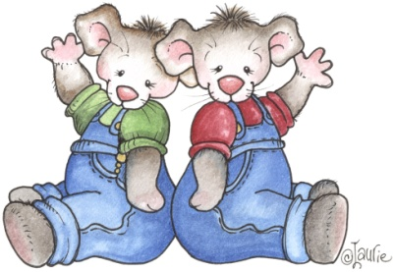
Fridge Notes: The Question Game
By Dr. Jane Baskwill
Faculty of Education
Mount Saint Vincent University
Halifax, Nova Scotia, Canada
www.janebaskwill.com
Questioning is a good way for parents to foster thinking, develop speaking vocabulary and to encourage longer sentence use in children. At school, your child will be asked to read and to write complete sentences and will be asked to create questions. In order to do this successfully, your child needs to learn to think in complete sentences and practice the difference between asking and telling. The Question Game is good practice for these reading and writing skills.
Here is how to play.
In advance, find some pictures of common signs or select products you have on hand in the kitchen [i.e. the McDonald’s sign, a supermarket sign, a can of soup, a box of cereal, etc.].
Tell your child you are going to play The Question Game. Explain how it works [“I am going to ask you a question about a place we go or something we use. Your job is to answer the questions. Let’s see how many questions I can think of and how many you can answer.”]
Ask your child to turn over one of the pictures or to choose one of the grocery items from a shopping bag.
Start with “What is this?”
Depending on your child’s response ask another question. For instance, if you are questioning about a box of Fruit Loops it might go like this:
Parent: What is this? Child: Fruit Loops!
Parent: What do we do with it? Child: Eat it? Parent: Yes, we eat it.
Parent: When do we eat it? Child: For breakfast. Parent: Can you say ‘We eat it for breakfast’?
Model the response you want in order to have your child answer in complete sentences. You can also ask questions such as: Can you tell me about the picture on the package? What shapes do you see?
Continue until you can’t think of any more questions or until your child seems to losing interest or the questions are becoming too difficult. You can continue the game with another picture or object if your child is willing or stop until next time.
Some Tips and Suggestions for Questioning:

- Ask “what” questions: Point to the item and say, “What’s this?” or
“What’s this called?” Avoid questions that your child can answer with a “yes” or “no,” or by pointing.
- Follow answers with questions: When your child names an object, ask a
question about it. For example: “What color is the sign?”, “What is this part of the soup can called?”, “What is the toucan doing?”, or “What do we use paper towels for?”
- Repeat what your child says: Let your child know his or her answer is correct by repeating it back: “Yes, that’s a grocery cart.”
- Help your child as needed: If your child isn’t able to answer your question,
give the correct answer and ask him or her to repeat what you have said.
- Praise and encourage: Tell your child when he or she is doing well by saying
things like: “Good talking!” or “That’s right. Good job!”
- Follow your child’s interests: If your child shows an interest in playing the game at another time either by asking you a question or requesting the game, pick up on it by responding to your child’s questions or asking questions as before.
