Javi Can Write: A Parent’s Guide to Early Stages of Writing Development
By Suzanne Scarboro

I was at the park, crowing at full volume in Spanish over every wild hair mark made by my preschoolers (and their growing group of associates) as they wrote on the pavement with chalk. A mom – I’ll call her Juana - came over to see what all the fuss was about. We chatted. She commented, looking at my chalk writers, that her son Javi doesn’t write. His kindergarten teacher told her that, at writing time, Javi just sits there. “No escribe nada.”
Juana looked worried. You might look worried, too. Sure, about Javi, but also about your own hijo. Maybe your child is 3 or 4 or 5, in preschool or kindergarten, and not writing much either. Well, at least not writing in a way that is conventional. Most kids’ writing goes through a fairly predictable sequence of stages, and it’s likely that Javi (and your child, and mine) is somewhere along a normal developmental spectrum of writing ability. I’m going to describe some stages of writing development so you can see where your child is right now and also where, when you’re writing together, you can guide her to go next.
Stages of Writing Development
A cat’s meow of a teacher/writer named Isabell Cardonick wrote a book called Kid Writing (published in 1999 by the Wright Group). In it, she presents the terms I’ll use to talk about the early stages of writing development.
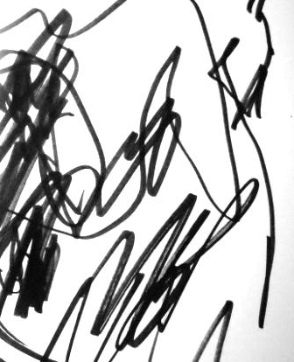
Maybe your child’s writing is in what Cardonick (and I, and other preschool teachers) would call the emerging stage. She is learning how to hold a pencil or a pen and developing the small muscles that she needs in order to write more conventionally. Her writing might look like the writing shown to the right. I know it doesn’t look a lot like writing yet. But it is. It’s the beginning. Your emergent writer can scribble a picture. Then you can ask her to write what it is, and she can scribble her story. “Let’s write your name!” I can exclaim at preschool while beckoning her to join me in closely scrunitizing her name card; she’ll scribble for me with a flourish and a grin. Scribbling is awesome. Try it. You might find it to be surprisingly satisfying.
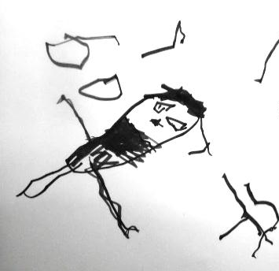
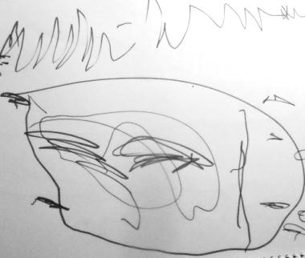
Your preschool age son might be in the next stage of writing development, the pictorial stage. He can draw a picture and you both can look at it and see what it is. The picture shown at left is a cerdito. No mistaking it, right? Piggie. Loud and clear. See the writing below the picture? It looks different. Maybe you thought it was grass, but those up and down lines are the fantastic refinement of all that scribbling practice, and they represent print. Believe me, and believe your child too (who -¡Bravo!- is beginning to see that pictures and print are different!), when we tell you that that bit, down at the bottom? It says “cerdito.”
In the next stage, called the precommunicative stage, children need to spend some time working out what letters look like. Your child might make things that resemble letters, but aren’t, or even write a few letters (often from her name or copied at random from an alphebet chart), and read you her letters and letter-like markings as her story. Her writing in this stage might look like the writing at right. -Dime lo que escribiste- you might say. Or, if you’re doing it in English, “Tell me what you wrote.” She might say that it says “Once upon a time there was a dancer and she leapt through the air like a silk scarf caught in the wind, and her heart sang with a dizzy and enormous song and it was the song of feeling loved by the sky and the clouds, and loved, truly loved, by the sun.” (Just the way she herself feels loved by you when you are sitting here together writing her writer-ness into being.) She might say that if you do lots of reading aloud to her—which, of course, you do. And then, “The end.” And a slightly mispronounced but still recognizable, “Y colorín colorado, este cuento se ha acabado.” There’s the “Colorín colorado…” bit up in the far right corner--the scraggly elephant trunked “R”. Yes, that’s it. It’s a whole spectacular rhyming sentence in her second language extracted directly from last week’s preschool circle time. Treat it as such, because what it is, as much as a sentence, is a mark that your child is right in the middle of learning that, no matter what her skill at laboriously scratching out those letter “thing-ies,” she has a story to tell and it’s entertaining and attention-grabbing and definitely worth all that hard, hard work of figuring out how to make letters. One more note about this stage: Often, by this stage, kids have practiced tons with you at home and with a teacher (and AWESOME parent volunteers) at preschool or kindergarten and can copy or even independently write their names. For some kids at this stage, their name is all they want to write for a while. “What shape did you draw here?” “EMMA.” -¡Mira tu tigre!¿Quieres escribir ‘tigre’?- “¡Sí! EMMA.” There are few more things more important to be able to write than one’s own name. It’s worth doing again and again.
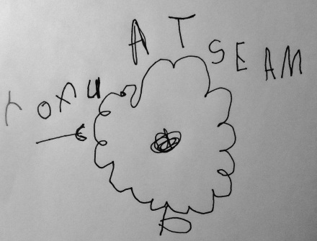
In the semiphonetic stage, kids have often already gotten lots of coaching from teachers and parents about which spoken sounds go with which written letters (in their names and in other words as well), and they’ve practiced and practiced and practiced matching sounds to letters and writing them down. They can hear the beginning sounds of words as they say them, and they can visualize the written letters that go with those beginning sounds. If your child is in the semiphonetic stage, he might write, “MPMQ” for “Mi papi me quiere” or, in English, “MDLM” for “My daddy loves me.” With practice, and with coaching on how to “rubber band” or verbally s-t-r-e-t-c-h out words so that they can hear separate sounds in them, children will begin to include more and more of the letters in the words they want to write. Sometimes children in this stage write backwards, from right to left instead of left to right. The child whose writing is pictured here wrote to me, “Maestra, es una flor” (Teacher, it’s a flower) from right to left. Can you read it? Brilliant boy.
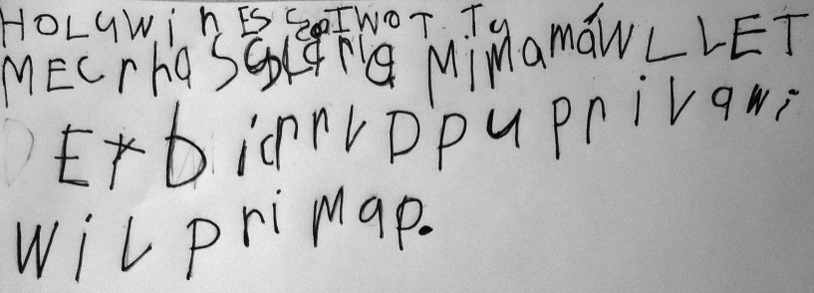
My daughter Momo, who is in kindergarten, is in the phonetic stage. Her writing is typical of that stage in that she represents words with beginning, middle and ending sounds, spells some short, commonly used words correctly, and jots down multiple sentences on her chosen topic. She frequently forgets to use spaces and punctuation. She code switches, or switches from Spanish to English and back, as she writes, but she has not yet learned how to demarcate these switches in print; this makes it difficult, at times, to decipher her stories. Here’s a sample of her writing from October. This one’s about Halloween: “HoLuwin.” There I am written into it: “Mi mamá.” Look. Second line. “Mi mamá will let me carve a pumpkin and we will put….” I can’t remember what it was that she said we would “put” now. I wish I could. I want her voice to come through.
We all want our kids to learn to write. We want them, ultimately, to be able to get their messages across to us, to their teachers, and to whatever audience of readers they might seek. We want them to show up at kindergarten with an idea of what they should do when their teacher tells them that it’s writing time, and we want them to be able, someday, if they choose, to mark and shape the world with the power they will hold in their written voices.
Javi can write. So can Momo. And if your child isn’t writing yet in a way that is conventional, he can, or she can, too. They’re on their way. Lean in. Listen. Our kids can do it. And we, as parents, can help by seeing clearly what it is our kids are doing right now, and guiding them from here forward, one scribble, and one letter, and one line at a time.

