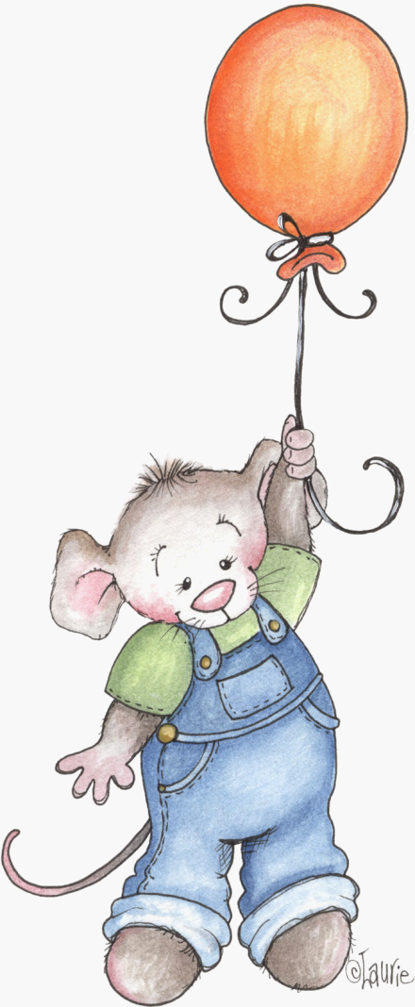
FRIDGE NOTES: WAYS TO ENCOURAGE YOUNG CHILDREN’S WRITING
Jane Baskwill

Just as you did when your child was learning to walk and talk, it is important for you to provide warmth, acceptance, confidence and belief in your child as a written language user. As you create a safe environment, free from criticism and over-correction, your child will feel confident to take risks and experiment with early writing forms.
REMEMBER:
- Marks on the paper are the early forms of writing. Ask your child to tell you what they say.
- Pictures and scribbles are also forms of writing. Encourage your child to tell you what he/she is thinking. Write their responses at the bottom of the page.
- Encourage your child to write about their pictures by saying “Write what you want to say about your picture.”
- When your child is uncertain about how to write, say “Write it the way you think it should be.”

