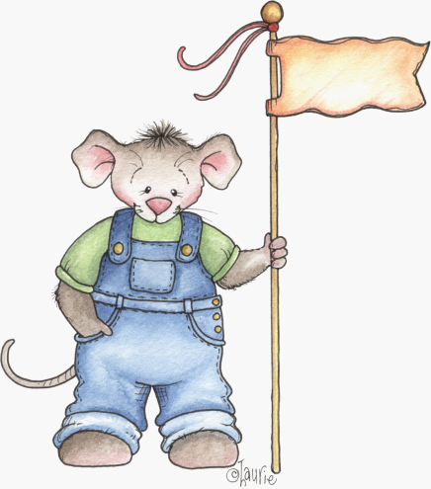
FRIDGE NOTES: IMAGINATIVE PLAY
By Dr. Jane Baskwill
Faculty of Education
Mount Saint Vincent University
Halifax, Nova Scotia, Canada
www.janebaskwill.com
Most young children engage in imaginative play easily and naturally. Here’s how you can help:
- Provide opportunities, space and props. For example, a blanket for a tent, empty toilet rolls taped together to use as binoculars, box of dress-up clothes can be used to encourage and maintain your child’s interest.
- Participate some of the time. You will make a great giant, troll, or even a hero who saves the day! Take your lead from your child. You can also suggest you both act out a favourite story. Invite other family members or your child’s friends to play too.
- Invite your child to make up stories and tell them to you or to tell you a true story about something that has happened or they have done. Be sure to be attentive and listen closely [Turn off the TV so your child won’t get distracted].

Tips and Suggestions
Almost any favourite story can be acted out. If your child needs more “actors” to play some of the parts, he/she can use puppets or stuffed animals to help out!
Don’t always expect your child to act out the story completely accurately. Allow your child to take liberties with the tale. This is a sure sign that they likely know the story inside-out and backwards and that their creative juices are flowing!
Stories to Act Out

Fairy Tales
The Three Pigs
Goldilocks and the Three Bears
Red Riding Hood
Mother Goose Rhymes
Old Mother Hubbard
Jack and Jill
Little Miss Muffet

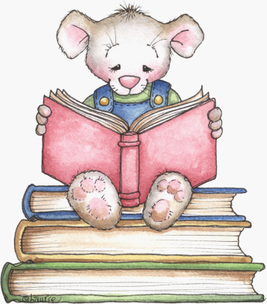
Picture Books
for Imaginative Play:

The Very Hungry Caterpillar by Eric Carle
Bark George by Jules Feiffer
Caps for Sale by Esphyr Slobodkina
If You Give A Mouse A Cookie by Laura Numeroff
The Mitten by Jan Brett
The Three Bears by Jan Brett
The Gingerbread Man by Jan Brett
The Three Billy Goats Gruff by Paul Galdone
Who Sank The Boat by Pamela Allen
We’re Going on a Bear Hunt by Michael Rosen
Not a Box by Antionette Portis
Not a Stick by Antionette Portis
In the Small, Small Pond by Denise Flemming
Imagine by Alison Lester
The Little Red Hen by Paul Galdone
The Three Little Pigs by Paul Galdone

