"In Defense of Good Teaching" Award

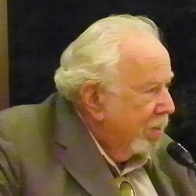 Kenneth S. Goodman

This award was established to honor professional educators who have stood up to laws, policies, and practices in an extraordinary way and have set an example of well grounded, humanistic, holistic education. Read more at www.coe.arizona.edu/tls/goodman_award to view the list of former award winners.

Nominating Procedures
The Department of Teaching,, Learning and Sociocultural Studies (including the Program in Language, Reading and Culture) in the College of Education at the University of Arizona seeks nominations for this award given in honor of Kenneth S. Goodman, recognized internationally as an advocate for teachers, political action, holistic education and his comprehensive theory of reading. Nominations for the 2016 award will be accepted anytime until November 30, 2015.

Review the following criteria and procedures. Nominate a courageous educator you believe deserves this recognition and you are welcome to self nominate. The award winner will be invited to attend a reception in his/her honor and to speak at a departmental Annual Conference often held in the spring. (sponsored by the Kenneth and Yetta Goodman endowment)

Criteria
The criteria for the award include:
A professional educator at any level who has experienced economic or social consequences as a result of "standing up." Preferably an educator connected to literacy teaching and teacher education.

Procedures
Procure the approval of the nominee in writing since she/he may have to release materials from personal files to supply supporting information.
Send a letter of nomination (or self-nomination) and the following documentation:
Curriculum vitae/résumé and 3 names of references (include phone numbers, emails and addresses).
Attach supporting evidence such as newspaper clippings, letters and memos, articles or position papers.

Send documentation to:
Dr. Elizabeth Jaeger
In Defense of Good Teaching Committee Chair
Teaching, Learning and Social Cultural Studies,
College of Education, University of Arizona.
1430 East Second Street
Tucson, AZ 85721

