School of Education
Department of Teaching, Literacy and Leadership
Literacy Studies Faculty invite you to join us at our 9th

Reading Miscue Analysis Conference
July 15 – 17, 2013 – 9 a.m. to 4:30 p.m.
Hagedorn Hall

This conference brings educators together to explore miscue analysis in research, evaluation, teaching and community literacy projects. This small, focused conference provides invites conversations among participants. Mini-courses include Introduction to Reading Miscue Inventory and Advanced Topics.
Plenary sessions
Evolving toward applicable theories and theoretically-based applications: Two complementary histories Peter Fries, Central Michigan University Ken Goodman, University of Arizona
Reading Miscue Inventory/Retrospective Miscue Analysis: Reflexive Practices in Community Settings
Heidi Bacon, University of Arizona Edie Lantz Leppert, Literacy Volunteers of Tucson
Reading in Mandarin and English: A Case Study of RMI and RMA of College ELL Students
Yang Wang, University of Missouri –Columbia
Eye Movement Miscue Analysis (EMMA) in Readers with Communication Disorders: Strategies of Making Sense with Storybook vs. Self-Authored Texts
Ryan Nelson, Jack Damico University of Louisiana – Layfayette

EMMA RESEARCHERS ANNUAL MEETING
Eye Movement Miscue Analysis (EMMA) Researchers annual meeting open to all:
Wednesday, July 17 from 3 p.m. to 6 p.m. and Thursday, July 18 from 8:30 a.m. to 10:30 a.m.

For information regarding professional development registration, call the Office of Professional Development at (516) 463-5750 or visit Office of Professional Development.

http://www.hofstra.edu/academics/colleges/soeahs/cwpd/

Two graduate course options:
LYST 244 Advanced Retrospective Miscue Analysis 3 s.h. Course Code (CRN): 70296
LYST 353 - Workshop in Miscue Analysis 1 s.h Course Code (CRN): 70288

Additional information: debra.goodman@hofstra.edu or alan.d.flurkey@hofstra.edu

The Reading Miscue Analysis Conference held in conjunction with Literacies for All Summer Institute

LITERACY IS A HUMAN RIGHT
2013 Reading Miscue Analysis Conference – July 15 – 17, 2013

FEES AND REGISTRATION INFORMATION

Reading Miscue Analysis Conference – July 15 – 17, 2013

Monday – Wednesday, July 15 – 17, 2013 (9 a.m. – 4 p.m.) Hofstra University - Hagedorn Hall 284, 285

In conjunction with the WLU Literacies for All Summer Institute – July 18 – 20, 2013
If attending the institute, you must register at NCTE/WLU Literacies for All Summer Institute

Graduate Credit Options – two courses are available:
Graduate credit is $1055 per semester hour plus standard university fees. Hofstra students may register on-line at my.hofstra.edu. Non Hofstra students may register at Memorial Hall. (516-463-8000)
LYST 244 Advanced Retrospective Miscue Analysis 3 s.h. Course Code (CRN): 70296
Meets: July 15 – 17 9 a.m. to 4 p.m., July 18 7 p.m. – 9 p.m., July 19 & 20 8:30 a.m. – 5:00 p.m.
Student registration for Literacies for All Summer Institute is required in addition to course registration.
LYST 353 - Workshop in Miscue Analysis 1 s.h Course Code (CRN): 70288
Meets: July 15 – 17 from 9 a.m. to 2:30 p.m. (Additional scheduling options available.)

Graduate Course Information: contact Alan Flurkey (alan.d.flurkey@hofstra.edu) or (516) 463-5237 or

Debra Goodman (debra.goodman@hofstra.edu) or (516) 463-5563.

Professional Development Non-Graduate-Credit Options:
Three Day Conference (July 15 - 17): $150 ($75 for student – copy ID card required)
Special rate for registered participants in the Literacies for All Summer Institute: $100
Registration form below, together with a check payable to Hofstra University, should be mailed to:

Betsy Salemson, Director
Office of Professional Development Services
School of Education/ 120 Hagedorn Hall
119 Hofstra University
Hempstead, NY 11549 – 1190
PHONE: (516) 463-5750 FAX: (516) 463-4370

Registration Information: contact Betsy Salemson: ( Betsy.A.Salemson@hofstra.edu ) or (516) 463-5750.

CONFERENCE TRAVEL AND HOUSING INFORMATION IS AVAILABLE THROUGH

http://www.ncte.org/wlu/institute

Registration Form – Literacy Studies - Reading Miscue Analysis Conference 2013
Name Title/Position

School Affiliation

Work Address
Work Telephone Fax: E-mail

Home Address
Home Telephone Fax: E-mail
_____ $150 Registration for three day registration at Reading Miscue Analysis Conference. July 15-17, 2013.
_____ $100 Special rate for registered participant in the Literacies for All Summer Institute.
_____ $50 Hofstra student with ID # _______________________
_____ $75 Non-Hofstra student: School & ID # _____________________________________________
or Hofstra alumni with previous ID # ________________________
Enclose check payable to Hofstra University and mail to Office of Professional Development Services (address above).
Special group rates available. Visa/MasterCard also accepted. Call: (516) 463-5750.

Reading Miscue Analysis Conference

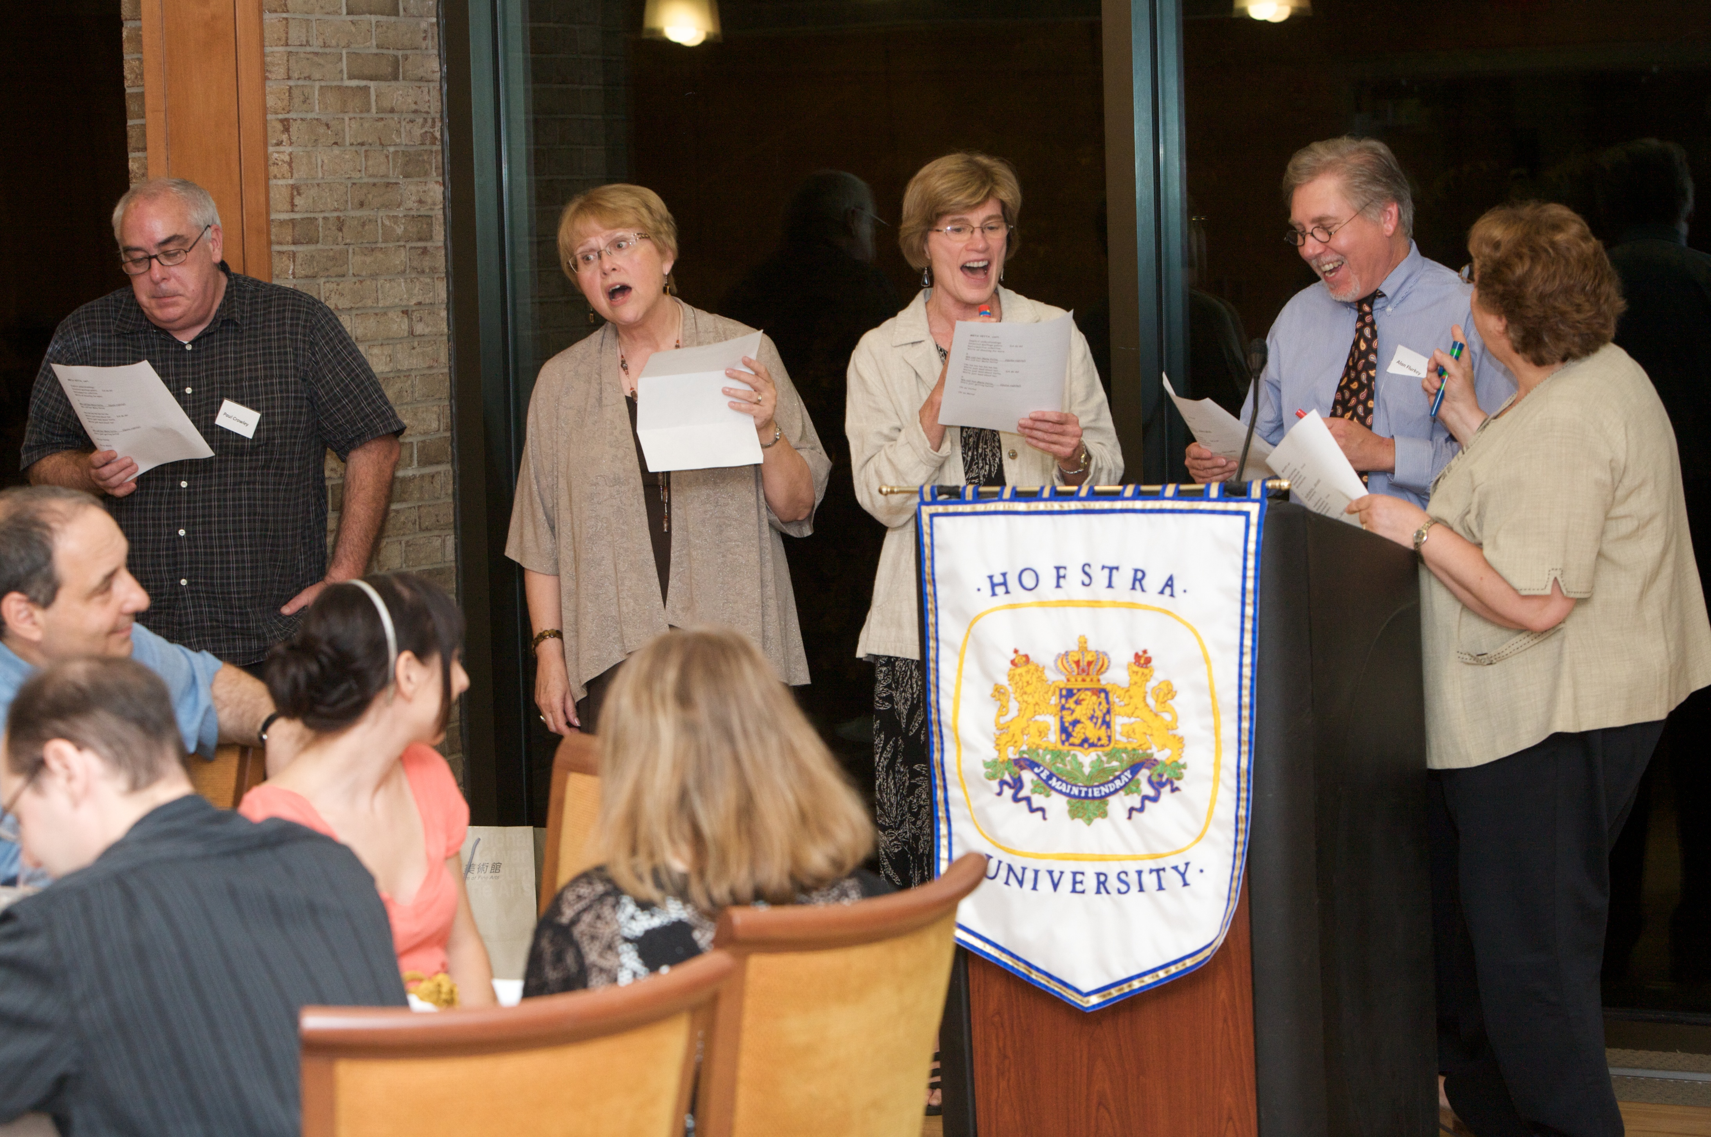
Additional Information

Hofstra University is in Hempstead, NY 11549
For directions to campus and a printable campus map, please visit www.hofstra.edu/directions.
Airports:
LaGuardia and JFK are both about 30 minutes away.
Do not take yellow cabs from LaGuardia or JFK airports. They have to charge double to Long Island. (See Ground Transportation.)
Southwest Airlines flies to LI/Macarthur Airport – about 45 minute drive from Hofstra.
Ground Transportation from LaGuardia and JFK:
Founding Mothers: Yetta Goodman, Dorothy Watson, Rudine Sims Bishop, Carolyn Burke.
Private Car (Reserve in Advance):
Silver Eagle 516-455-5768 ($60 for up to 3 people.)
Taxi (Reserve in Advance): All Island Taxi 516-333-3131 (Ask for price when reserving. About $35.)
Check for coupons: http://allislandtransportation.com/coupons.html
Shared Ride: Super Shuttle http://www.supershuttle.com (First passenger $45, Additional $10)
AirTrain: From JFK, the AirTrain goes to Jamaica Station ($5) where you connect with the Long Island Railroad (LIRR) to Mineola, Garden City, or Hempstead ($5 to $7 purchase on platform). Take a cab to hotel.
Long Island Railroad (LIRR): http://www.mta.info/lirr/
MTA Subway & Bus Information: http://www.mta.info/
Train:
Amtrak Trains take you to Penn Station. From Penn Station, take the Long Island Railroad to Mineola (close to hotels and more frequent service) or Hempstead. (See above for LIRR link.)
Manhattan: Manhattan is about 45 minutes from Hempstead by train or car. There are frequent trains to Penn Station. Discount Broadway or event tickets, try nytix.com.
Beaches: Hempstead is about a 15-minute drive from Jones Beach and the Atlantic Ocean. It’s a one to two hour drive (or train ride) to the Hamptons for vacationers.
Hotels Near Hofstra University:
The following are hotels in the area and the rates they charge Hofstra conference attendees. Let them know you want the Hofstra rate listed below. Hampton Inn: Garden City Hampton Inn. Use the code “WLU.” Other hotel prices may vary.
- Hampton Inn, Garden City $145 (516) 227-2720
Breakfast, pool and amenities. Near shopping, large mall, restaurants. Under 3 miles from Hofstra.
- Hyatt, Garden City $145 (516) 222-6277
Breakfast, internet, and amenities. Next to the Hampton Inn. Under 3 miles from Hofstra.
- The Hilton Garden Inn, Westbury (516) 683-8200
About 5 miles from Hofstra. Mall and restaurants a short walk away. Breakfast for purchase.
- La Quinta, Garden City (516) 705-9000
About 2.5 miles from Hofstra. A bit isolated – long walk to mall. Breakfast included.
Dorm housing is also available this year. Information available at ncte.org/wlu: Literacies for All Housing Information

