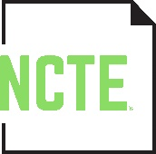
EDWYNA WHEADON POSTGRADUATE TRAINING SCHOLARSHIP FUND APPLICATION FORM

Name:

Current Job Title:

School Information:
Name:
Address:
City, State, Zip:
Phone:

Email:

Highest Education Level Completed: ____ Bachelor ____ Master ____ Doctorate

Years of Teaching Experience:

NCTE Member Reference (optional but preferred):
Name:
Address:
City, State, Zip:
Phone:
Email:

Applicant Statement
On a separate piece of paper and written in no more than 500 words, please indicate the professional development experience for which you seek support. (Please include specific details such as course titles, planned dates of your study, fees, etc.) As part of your request, please tell us why you feel that you should be considered for this scholarship and how it will serve you in your career.

____________________________________________________________________
Signature of Applicant Date

Send the completed, signed application form and 500-word explanation statement by January 31 to college@ncte.org or by postal mail to NCTE Edwyna Wheadon Postgraduate Training Scholarship Fund, 1111 W. Kenyon Road, Urbana, IL 61801-1096.

