NCTE ORBIS PICTUS AWARD
FOR OUTSTANDING NONFICTION FOR CHILDREN
APPLICATION FORM

Name:

Affiliation (School/University):

Email address:

Please respond to the following:

- Why do you want to serve on the NCTE Orbis Pictus Award committee?

- What strengths will you bring to the committee?

- Have you served on or are currently serving on other book award committees? If so, what?

- Have you served on or are currently serving on any NCTE committees? If so, what?

- If you currently write or review books for journals, blogs, or other review or educational outlets, please provide the journal name or URL.

Submit your response to these questions along with your vita/resume and sample book annotation (all together in PDF format if possible) to:

NCTE Orbis Pictus Award Committee
elementary@ncte.org

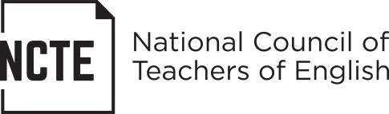

www.ncte.org/awards/orbispictus

