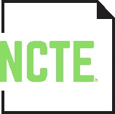
OUTSTANDING ELEMENTARY EDUCATOR
IN THE ENGLISH LANGUAGE ARTS AWARD

NOMINATION FORM

Name of Nominee:
Institutional Affiliation:
Institutional Address:
Phone / E-mail:
Home Address:
Phone / E-mail:

In 300 to 500 words, please explain how the nominee exemplifies the award criteria.

Award criteria:
- dramatically influenced literacy classroom practice
- made ongoing contributions to the field of literacy
- obtained national and/or international influence in literacy teaching and learning
- contributed a body of work that is compatible with the mission of NCTE
Nominated by:
Address:
Phone / E-mail:

Submit the completed Nomination Form by November 15 to elementary@ncte.org
or mail to: NCTE Outstanding Elementary Educator Award, 1111 W. Kenyon Road, Urbana, IL 61801-1096.

We will also accept the Nomination Form in person at the Elementary Section Get-Together during the NCTE Annual Convention.

NOTES: One nomination per NCTE Elementary Section member only. Please check the website http://www.ncte.org/awards/elemeducator for a list of past awardees.

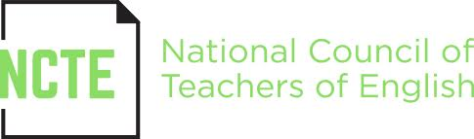

www.ncte.org/awards/elemeducator

